Junior Maths Extension Course

Measurement

Contents
Pythagoras’s Theorem 3
A simple proof of Pythagoras/Baudhayana’s Theorem: 6
Area of a square using the diagonal 7
Questions 7
Answers 8
Important ratio triangles to know 9
Fences 11
Deriving the formula for areas of quadrilaterals 12
Quadrilateral Area Answers 13
Applying area formulas 14
Answers 16
Circular measure 18
Parts of a circle 18
What is π? 18
Deriving π by exhaustion 19
Task 19
Answers 20
Deriving the area of a circle 21
Worksheet 22
Useful Formulas 23
Deriving the formula for the area of a sector 23
Deriving the formula for the length of an arc 23
Questions 24
Answers 26
Volumes of prisms 29
Areas of regular n-gons 48
Questions 48

Pythagoras’s Theorem
What you may know as Pythagoras’ Theorem was in fact around centuries before Pythagoras was born.
Baudhayana was an Indian mathematician who wrote a number of sutras (texts), including the sulbasutra which was dedicated to mathematics.
In his sulbasutra, Baudhayana defined what later became known as the Pythagorean Theorem, as well as an approximation for the square root of 2 (something that actually broke up the Pythagorean society).
The theorem states: The areas (of the squares) produced separately by the lengths of the breadths of a rectangle together equal the area (of the square) produced by the diagonal.
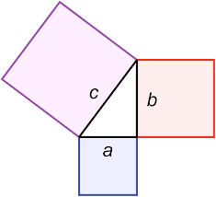
Effectively, this means that if we took the diagonal side length in a right-angle triangle (c in the diagram at right), and formed a square, the area would be c². If we did this with the other two sides, a and b, the sum of those two areas would give the same area. In other words:
$$a^{2}+b^{2}=c^{2}$$

Example
Given a triangle where we know the two shorter sides, we can use this equation to find the longer side (called the hypotenuse).
6cm
x
8cm

$$x^{2}=8^{2}+6^{2} \\ x^{2}=64+36 \\ x^{2}=100 \\ x=\sqrt{100} \\ x=10$$

When we know the length of the hypotenuse and only one of the shorter sides, we rearrange the formula:
25
x
24

$$x^{2}+{24}^{2}={25}^{2} \\ x^{2}={25}^{2}-{24}^{2} \\ x^{2}=49$$$x=7$

Questions
Question 1
Calculate the length of AB
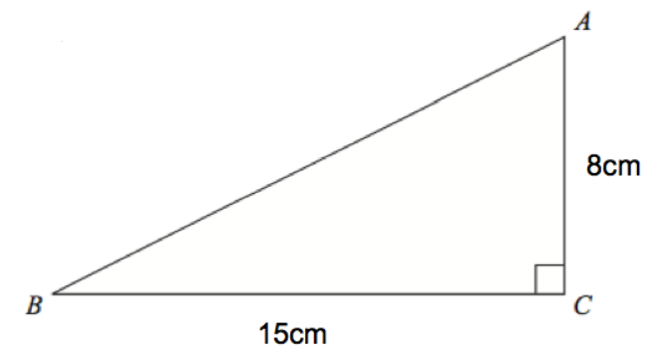
Question 2
Calculate the length of BC to 1 decimal place.
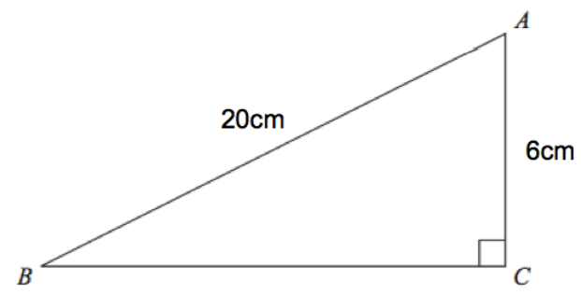
Question 3
Calculate the length of AB
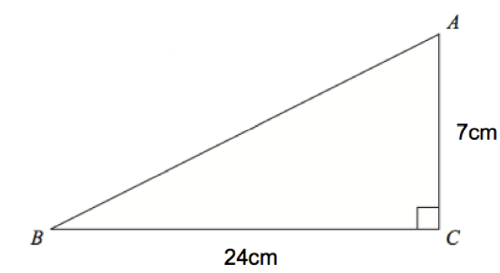
Question 4
Calculate the area of the triangle
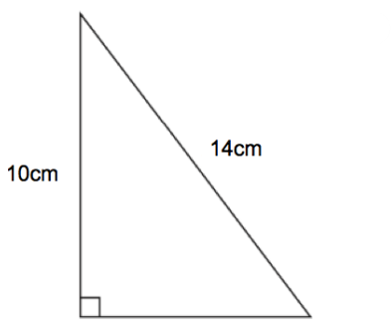
Question 5
Calculate the length of CD and the area of triangle ACD
D
C
B
A
3cm
7cm
10cm

Answers
Question 1
$${AB}^{2}=8^{2}+{15}^{2} \\ {AB}^{2}=289 \\ AB=17$$
Question 2
$${BC}^{2}+6^{2}={20}^{2} \\ {BC}^{2}={20}^{2}-6^{2} \\ {BC}^{2}=364 \\ BC=19.1$$
Question 3
$${AB}^{2}=7^{2}+{24}^{2} \\ {AB}^{2}=625 \\ AB=25$$
Question 4
$$b^{2}={14}^{2}-{10}^{2} \\ b^{2}=96 \\ b=9.8$$
Area = $\frac{1}{2}×9.8×10=49$
Question 5
$${BD}^{2}+7^{2}={10}^{2} \\ {BD}^{2}=51 \\ BD=7.14$$
$${{CD}^{2}=7.14}^{2}+3^{2} \\ CD=7.75$$
Area = $\frac{1}{2}×10×7.14=35.7$

A simple proof of Pythagoras/Baudhayana’s Theorem:
Consider the triangle:
b
c
a

If we take that same triangle and arrange it into a large square, with side lengths of a + b, and a square with side lengths c in the centre, we get this diagram:
b
a
c
c
b
a
c
a
c
b
b
a

We know that the area of the outside square is equal to:
$A={(a+b)}^{2}=\left(a+b\right)\left(a+b\right)=a^{2}+2ab+b^{2}$

We also know that the area of each triangle is: $\frac{ab}{2}$
Since there are four triangles, and we know the area of the inner square is $c^{2}$, we can form another equation for the area of the outer square: triangle + inner square
$$A=4×\frac{ab}{2}+c^{2}=2ab+c^{2}$$

We cannot equate the two area formulas, giving:
$$a^{2}+2ab+b^{2}=2ab+c^{2}$$
Subtracting 2ab from each side gives:
$$a^{2}+b^{2}=c^{2}$$

Area of a square using the diagonal
We know that the area of square is $A=x^{2}$, where $x$ is the side length.
However, if we only know the diagonal of a square, we can also quickly calculate the area.
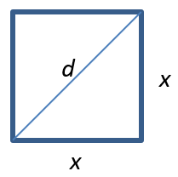
From Pythagoras’ Theorem, we know that:
$$d^{2}=x^{2}+x^{2} \\ d^{2}=2x^{2} \\ x^{2}=\frac{d^{2}}{2}$$
From this, you can see that if area is $x^{2}$, then area must also be $\frac{d^{2}}{2}$
Therefore, we have the formula: $A=\frac{d^{2}}{2}$
In words, the area of a square is half of the square of its diagonal.

Questions
Question 1
Find the area of the squares:
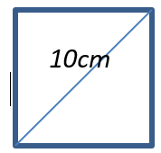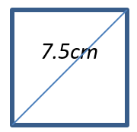
Question 2
If a square has an area of 450cm², what is the length of its diagonal?

Question 3
An ant starts in the corner of a square table that has sides of 1.2m. What is the shortest distance the ant can travel to reach the opposite corner?

Answers
Question 1
$$A=\frac{{10}^{2}}{2}=50{cm}^{2}$$
$$A=\frac{{7.5}^{2}}{2}=28.125{cm}^{2}$$

Question 2
$$450=\frac{d^{2}}{2} \\ d^{2}=900 \\ d=30$$

Question 3
$$A={1.2}^{2}=1.44m$$
$$1.44=\frac{d^{2}}{2}$$
$$d^{2}=2.88 \\ d=1.7m$$

Important ratio triangles to know
There are two very important right-angle triangles that come up in maths regularly, and you should be familiar with them so that you can recognise when to use them in solving problems.
The first one occurs when we have an isosceles triangle, so the other two angles are 45º. If we make the two shorter sides equal to 1, we get the following triangle:
45
$$\sqrt{2}$$
45
1
1

To check this works, use Pythagoras/Baudhayana: $1^{2}+1^{2}={(\sqrt{2})}^{2}$

The second occurs when we have a 30-60-90 triangle, as shown below. In this case, the side opposite the 30º angle will always be half of the hypotenuse. Using Pythagoras/Baudhayana, this means the remaining side will be $\sqrt{3}$.
60
2
30
1
$$\sqrt{3}$$

Using these triangles:
Since any triangle with the same interior angles is similar, this means that the ratio of their sides will be the same. For example, a 45º isosceles right-angle triangle will always have sides in the ratio 1-1-$\sqrt{2}$.
So, a 45º triangle with shorter sides of 3, must have a hypotenuse of $3\sqrt{2}$.
$$3\sqrt{2}$$
45
45
3

Example:
Find the length of the missing sides:
x
60
y
30
6

Since the side of length 6 is opposite the 30o angle, the hypotenuse must be 2x the length. The other side will be $\sqrt{3}$x the length.
$$x=2×6=12 \\ y=\sqrt{3}×6=6\sqrt{3}=10.39$$
Questions

Answers

Fences
Imagine you had 40 one-metre sections of fencing.
What is the largest rectangular area of land you could fence off?
Now imagine you could build your fence up against a wall, so you only need to use the fence for three sides of the enclosure:
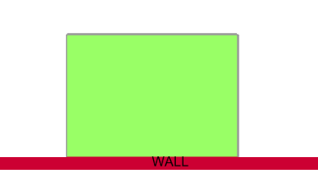
What is the largest area you can fence off now?
Now imagine you can attach the fence to the wall shown below, at the point marked X.
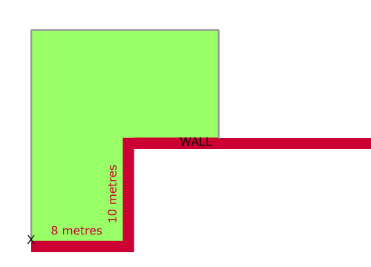
What is the largest area you can fence off now?
Extension
Could you enclose even greater areas if you had 40m of flexible wire fencing that could fence off curves as well as straight lines?

Deriving the formula for areas of quadrilaterals
We know the most common area formulas:
Rectangle Triangle
h
h
b
b

$A=\frac{b×h}{2}$ $A=b×h$

However, less known are the area formulas for the quadrilaterals below. Using algebra and your knowledge of these shapes (in particular their symmetries), derive the formulas for their area:
Shape | Properties | Diagram | Formula for area
Parallelogram | Two sets of parallel sides | h  b
Kite | One diagonal is an axis of symmetry | 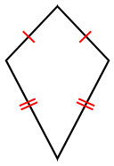
Rhombus | Both diagonals are axes of symmetry  All sides are of same length  Two sets of parallel sides | 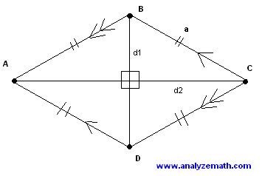
Trapezium | One set of parallel sides | 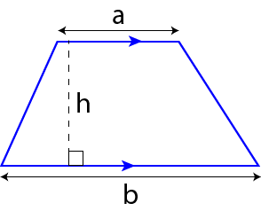

Quadrilateral Area Answers
Shape | Properties | Diagram | Formula for area
Parallelogram | Two sets of parallel sides | h  b | $$A=b×h$$
Kite | One diagonal is an axis of symmetry |   $$w$$  $$l$$ | $$A=\frac{l×w}{2}$$
Rhombus | Both diagonals are axes of symmetry  All sides are of same length  Two sets of parallel sides |   $$l$$  $$w$$ | $$A=\frac{l×w}{2}$$
Trapezium | One set of parallel sides |  | $$A=\frac{a+b}{2}×h$$

Applying area formulas
Use the area formulas we derived to solve the problems below.
Question 1
Find the areas of the following:
a) b) c)
20cm
20cm
10cm
14cm
10cm
4cm
12cm

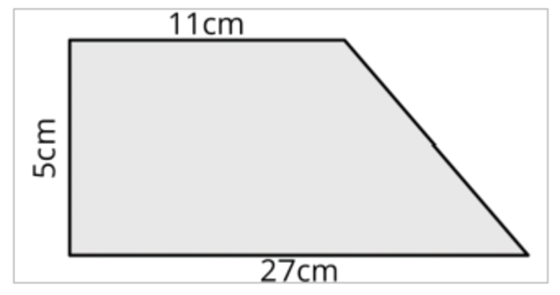
d) e)
8cm

10cm

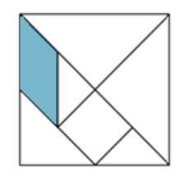
Question 2
The seven pieces in this 12cm x 12cm square make a Tangram set (they fit into the square perfectly).
What is the area of the shaded parallelogram?

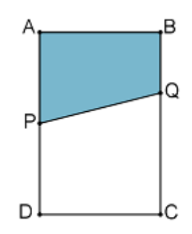
Question 3
ABCD is a rectangle. P is the midpoint of AD. The length of BQ is one third the length of BC.
What fraction of the area of the rectangle is the area of the shaded quadrilateral ABQP?

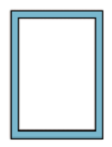
Question 4
A 30cm x 40cm page of a book contains a 2cm margin on each side, as shown.
What percentage of the page is occupied by the margins?

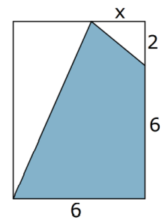
Question 5
Exactly three-quarters of the rectangle has been shaded.
What is the length of x?

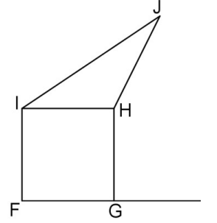
Question 6
The triangle HIJ has the same area as the square FGHI. FG has a length of 4cm.
What is the perpendicular distance from J to the extension of the line FG?

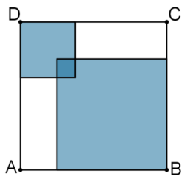
Question 7 (requires quadratic algebra)
The square ABCD has an area of 196 cm². It contains two overlapping squares; the larger of these squares has an area four times that of the smaller and the area of their overlap is 1cm².
What is the total area of the shaded regions?

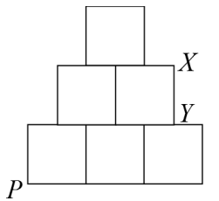
Question 8
The diagram shows a figure made from six equal, touching squares arranged with a vertical line of symmetry. A straight line is drawn through the bottom corner P in such a way that the area of the figure is halved.
Where will the line cut across the edge XY?

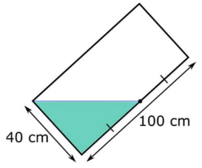
Question 9
A rectangle measuring 40cm x 100cm has dye on its surface. When the rectangle is tipped onto one corner so that the level of the dye reaches the bottom-left corner (as shown in the diagram), if reaches halfway up the longest side.
If the rectangle is tipped back onto its short side, how far up the longest side will the dye reach?

Answers
Question 1
a) $A=\frac{20+12}{2}×10=160{cm}^{2}$
b) $A=20×10=200{cm}^{2}$
c) Area = triangle + rectangle = $\left(\frac{1}{2}×4×4\right)+\left(4×8\right)=40{cm}^{2}$
d) $A=\frac{10×8}{2}=40{cm}^{2}$
e) $A=\frac{27+11}{2}×5=95{cm}^{2}$
Question 2
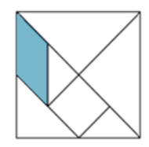
$$A=6×3=18{cm}^{2}$$
Question 3
We know that the answer is halfway between ½ and 1/3, therefore we just find the average of those values:
$$\frac{\frac{1}{2}+\frac{1}{3}}{2}=\frac{5}{12}$$

Question 4
Area of margin = $\left(30×40\right)-\left(26×36\right)=264$
Percentage = $264÷1200×100=22\%$


Question 5
Total area = 48, therefore the unshaded area is 12.
The area of the triangles are: $\frac{8(6-x)}{2}=24-4x$ and $\frac{2x}{2}=x$
Forming an equation: $24-4x+x=12$
$$24-3x=12 \\ 3x=12 \\ x=4$$

Question 6
Length IH = 4. Area of triangle HIJ = $\frac{1}{2}×4×h=16$
$$h=8$$Therefore, the perpendicular distance is 8 + 4 = 12cm


Question 7
Side lengths must be 14cm.
We know the side lengths of the two shaded squares add to 15, since the small square has area of 1.
Setting one square side to x, and the other to 15-x, we get:
$$x^{2}=4{\left(15-x\right)}^{2} \\ x^{2}={4x}^{2}-120x+900 \\ {3x}^{2}-120x+900=0 \\ x^{2}-40x+300=0 \\ \left(x-30\right)\left(x-10\right)=0$$Therefore x = 30 or 10, and must be 10 as 30 is too big.
The shaded regions are therefore: ${10}^{2}+{(15-10)}^{2}-1=100+25-1=124{cm}^{2}$


Question 8
Area of triangle formed will be 2.5, since half of the diagram is 3 and there is half a square at the bottom right outside of the triangle. The base will be 2.5
$$\frac{1}{2}×2.5×h=2.5 \\ h=2$$
Therefore, the line passes through X, which is at a height of 2.


Question 9
The area of the triangle is $\frac{1}{2}×40×50=1000{cm}^{2}$
When the rectangle sits on its 40cm side, the area is still 1000, but the formula for area is now $40h=1000$$$h=25cm$$
Therefore, the dye will reach 25cm up the longest side.

Circular measure
A circle is an example of a locus, which is a series of points all the same distance from another point (or points). In this case, a circle is made up of an infinite number of points all equidistant from a single point (the centre).

Parts of a circle
Radius – the distance from the centre of the circle to the circumference
Diameter – the distance from one side of the circle to the other, passing through the centre. Is equal to 2x radius
Circumference – the distance around the perimeter of the circle
Arc – part of the circumference
Chord – a line segment stretching across the circle, touching the circumference at each end
Segment – the area bound by a chord and an arc
Sector – the area bound by two radii and an arc
Arc
Circumference
Diameter
Radius

Tangent
Segment
Sector

Chord

What is π?
You will commonly see the symbol π whenever you are working with circles. π is related to the circumference and the diameter of a circle. No matter how large a circle is, if you take the diameter and lay it around the circumference of a circle, it will always fit exactly π times.
Video: Calculating Pi with real pies: https://www.youtube.com/watch?v=ZNiRzZ66YN0&ab_channel=Numberphile
π is an irrational number, which means it is a decimal that never repeats or terminates. It has been calculated to billions of decimal places, and no pattern has ever emerged.
Video: A mile of Pi
https://www.youtube.com/watch?v=0r3cEKZiLmg&ab_channel=Numberphile

Deriving π by exhaustion
Archimedes (and also various other early mathematicians such as Eudoxos) is credited with taking one of the biggest steps forward towards more accurate approximations. He came up with the first theoretical method of approximating pi, all based around regular polygons and circles.
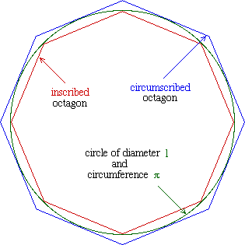
The premise is simple; draw a circle, then draw a regular polygon (for example an octagon) inside the circle, so that the vertices of the octagon touch the circle. Then draw another octagon, but this time so that the sides of the octagon touch the circle. If done correctly you should see a octagon, inside a circle, inside another octagon.
At right is what it should look like:
Archimedes discovered that as you increase the number of sides on the polygons, the area between the perimeters of the polygons and the circumference of the circle gets ever smaller. Eventually in theory the area gets so small that it becomes "exhausted", so the larger the number of sides on the polygon, the closer the polygon's perimeter becomes (in size) to the circumference of the circle. This fact can then be used to find a range of values, inside which $π$ must lie.

Task
Draw squares inside (inscribed) and outside (circumscribed) around a circle with radius of 1. Calculate the area of each square, getting upper and lower limits for π.
Repeat for a hexagon and see how the limits get closer together.
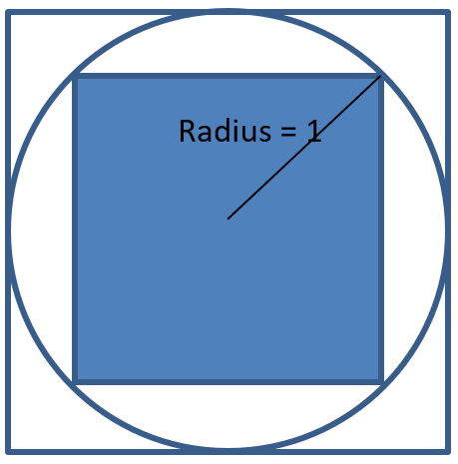
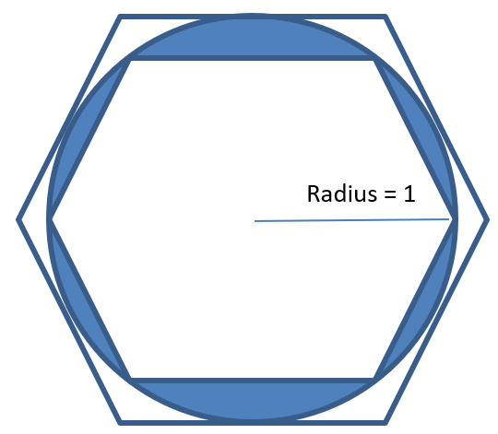

Answers

Radius = 1

Area of small square (using diagonal):
$$A=\frac{d^{2}}{2}=\frac{4}{2}=2$$
Area of large square:
$$A=bh=2×2=4$$

Repeating for a hexagon:
Each hexagon is made up of 6 equilateral triangles. We can use the $1, 2, \sqrt{3}$ ratio triangle to find their dimensions and hence their areas.
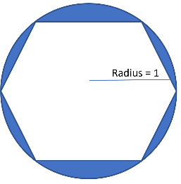
Small hexagon triangles are:
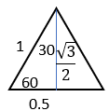
$$\frac{1}{\sqrt{3}}$$
$$\frac{2}{\sqrt{3}}$$
60
30
1
0.5
The area of each of these will be $A=\frac{1}{2}×1×\frac{\sqrt{3}}{2}=\frac{\sqrt{3}}{4}$
Therefore, the area of the hexagon is $6×\frac{\sqrt{3}}{4}=\frac{3\sqrt{3}}{2}=2.598$
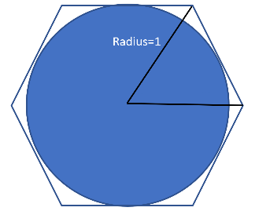
Larger hexagon triangles are:
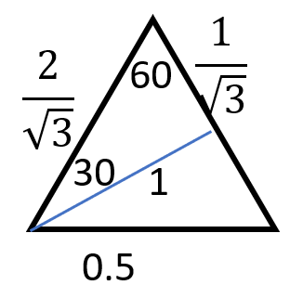

The area for each of these will be $A=\frac{1}{2}×1×\frac{2}{\sqrt{3}}=\frac{1}{\sqrt{3}}$
Therefore, the area of the hexagon is $6×\frac{1}{\sqrt{3}}=\frac{6}{\sqrt{3}}=3.464$

So, we know π is between 2.598 and 3.464, an improvement on 2 and 4 using the square.

Deriving the area of a circle
Since we know the circumference of a circle is π times the diameter, we also know that it will be twice π times the radius:
$$C=πd=2πr$$
We can use this to derive the formula for the area of a circle.

Cut a circle into four equal quarters, then cut them out. We can rearrange them as below to create a rough parallelogram.
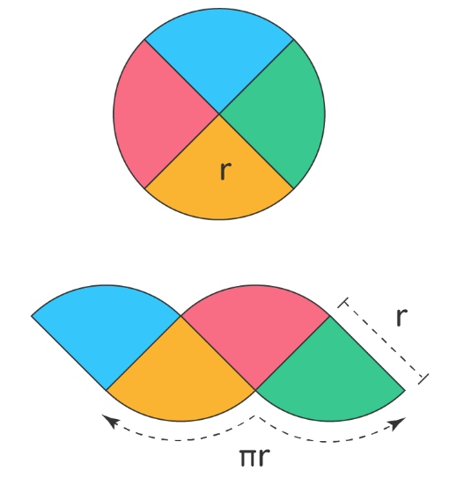
If we cut the circle into more and more even sectors, and continue to arrange them, eventually it will create a rectangle.
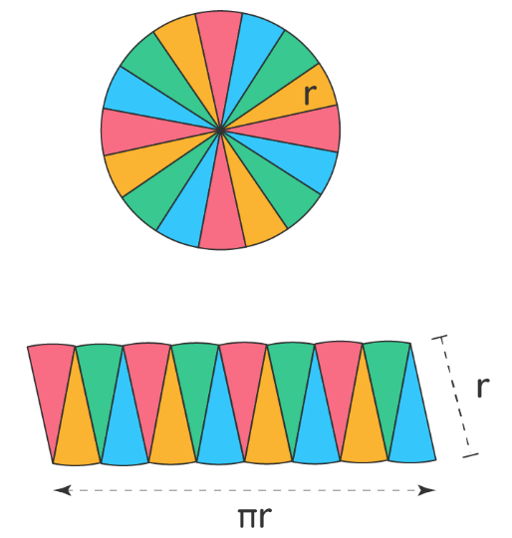

Worksheet
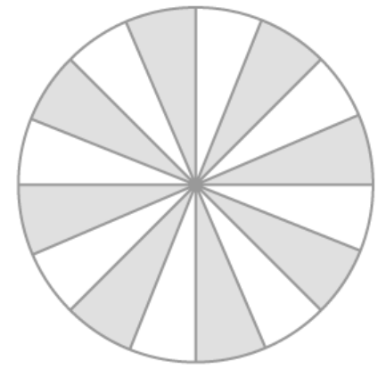



Useful Formulas
Note: r = radius, d = diameter, n = angle at centre

Area of a circle = $πr^{2}$
Circumference = $2πr= πd$
Area of a sector: $A=\frac{n}{360}×πr^{2}$
Arc length: $L=\frac{n}{360}×2πr$

Deriving the formula for the area of a sector

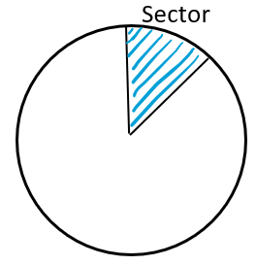
This is a fraction of a circle, so we just need to know what that fraction is. There are 360º in a circle, so we simply take the angle the centre of the sector and write it as a fraction out of 360.
We then find the area of the whole circle and multiply it by the fraction.
$$Area=\frac{n}{360}×πr^{2}$$

Deriving the formula for the length of an arc
This is similar to how we derived the area of a sector. We just need to find the fraction of the circumference that the arc takes up. The whole circumference is equal to $2πr$, so we just multiply that by the fraction.
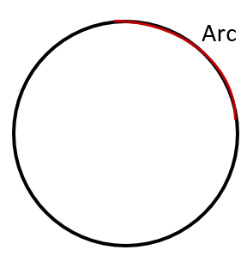
n
Arc length $=\frac{n}{360}×2πr$

Questions
Question 1
Calculate the area and the circumference of a circle with a radius of 5cm.

Question 2
If the circumference of a circle is 200cm, what is the area?

Question 3
Calculate the area of a circle with a diameter of 50cm.

Question 4
Calculate the area of the sectors:
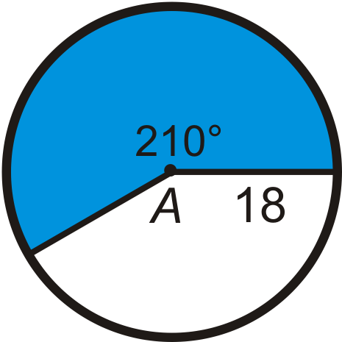
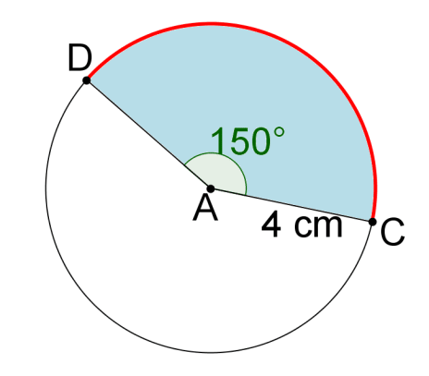
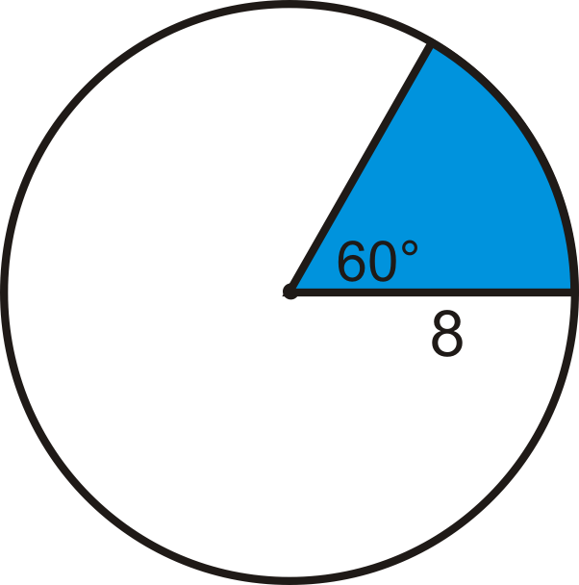

Question 5
Calculate the area of the segments:
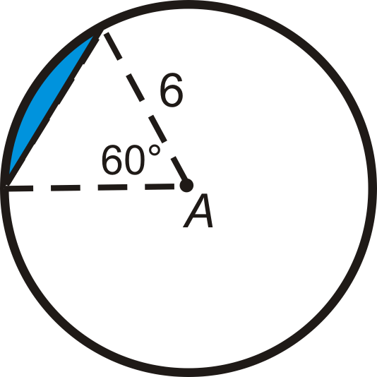
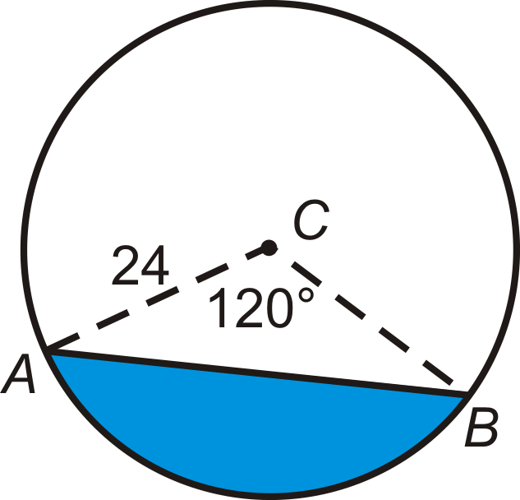

Question 6
A sector with an angle of 45º has an area of 400cm². What is radius of the circle?

Question 7
What is the perimeter of a sector with radius of 10cm and an angle of 30º?

Question 8
A round table can be made square by dropping the four leaves. If a side of the square table measures 120cm, to the nearest hundredth of a square cm, how much larger is the area of the table when the leaves are up?
120
120

Question 9
An 8-inch pizza is cut into 3 equal slices.
A 10-inch pizza is cut into 4 equal slices.
A 12-inch pizza is cut into 6 equal slices.
A 14-inch pizza is cut into 8 equal slices.
From which pizza would you take a slice if you want as much pizza as possible?

Question 10
If the area of a disc inscribed in a square is $36π$ cm², what is the area of the square?

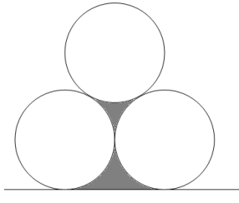
Question 11
The diagram shows three touching circles each of radius 5cm and a line that touches two of them.
Find the total length of the perimeter of the two shaded shapes.

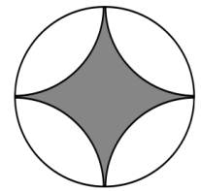
Question 12
The shaded region shown in the diagram is bounded by four arcs, each of the same radius as that of the surrounding circle.
What fraction of the surrounding circle is shaded?
(Hint: try drawing a square around the circle)

Answers
Question 1
$$A=π×5^{2}=25π=78.5{cm}^{2}$$
$$C=2π×5=10π=31.4cm$$

Question 2
$$200=2πr \\ r=\frac{200}{2π} \\ A=π×{(\frac{200}{2π})}^{2}=\frac{40000π}{4π^{2}}=\frac{10000}{π}=3183.1{cm}^{2}$$
Question 3
$$r=25 \\ A=π×{25}^{2}=625π=1963.5{cm}^{2}$$
Question 4
$$A=\frac{60}{360}×π×8^{2}=33.5{cm}^{2} \\ A=\frac{150}{360}×π×4^{2}=20.9{cm}^{2} \\ A=\frac{210}{360}×π×{18}^{2}=593.8{cm}^{2}$$
Question 5
Calculate the area of the segments:


Area = sector - triangle
$$A=\frac{120}{360}×π×{24}^{2}-\frac{1}{2}×12\sqrt{3}×12=478.5$$
$$A=\frac{60}{360}×π×6^{2}-\frac{1}{2}×3×3\sqrt{3}=11.1$$

Question 6
Sector is 1/8 of a full circle, therefore the area of the circle would be 1600cm².
$$πr^{2}=1600 \\ r^{2}=509.3 \\ r=22.6cm$$

Question 7
Perimeter is made up of two radii and an arc.
Arc length = $\frac{30}{360}×2π×10=5.2cm$
Perimeter = $5.2+10+10=25.2cm$

Question 8
To find the area of the circle we need to calculate the radius, and we can do this by first finding the diameter. By adding the diameter to the diagram we can quickly see that using Pythagoras’ Theorem will help us.
36
36

The diameter is found by $d^{2}={36}^{2}+{36}^{2}$$$d=\sqrt{2592} \\ d=50.91$$
This makes the radius equal to 25.45.
Area of the circle will be $π×{25.45}^{2}=2035.75$
Area of square is 36 x 36 = 1296 so the difference of areas is 2035.75 – 1296 = 739.75 square inches.

Question 9
Calculate the areas of each pizza, and then use this to work out the area of each slice.
8-inch pizza has area $16π$, so the slice is $\frac{16}{3}π$ cm².
10-inch pizza has area $25π$, so the slice is $\frac{25}{4}π$ cm².
12-inch pizza has area $36π$, so the slice is $\frac{36}{6}π$ cm².
14-inch pizza has area $49π$, so the slice is $\frac{49}{8}π$ cm².
Next, students need to compare the fractions and work out which one is the biggest. Lowest common multiple of each denominator is 24, so find equivalent fractions for each with 24 as the denominator.
$$\frac{16}{3}π=\frac{128}{24}π$$
$$\frac{25}{4}π=\frac{150}{24}π$$
$$\frac{36}{6}π=\frac{144}{24}π$$
$$\frac{49}{8}π=\frac{147}{24}π$$
So, the 10-inch pizza will give the biggest slice.

Question 10
The radius of the circle must be 6cm, so the diameter is 12cm. The square side lengths therefore are also 12cm, making the area of the square 144cm².


Question 11
The triangle formed by the radii is equilateral, therefore each angle is 60.
We can calculate the lengths of each arc: $L=\frac{60}{360}×2π×5=5.24cm$
60º
The shaded areas are made up of 5 arcs, plus the flat base which is the length of two radii.
10cm
Perimeter = $5×5.24+2×5=36.2cm$


Question 12
Square has side lengths of $2r$, therefore it has area of $4r^{2}$
r
r
There are four sectors, each a quarter-circle. Their combined areas are:
$$4×\frac{πr^{2}}{4}=πr^{2}$$
Therefore, the shaded area is $4r^{2}-πr^{2}$
The fraction shaded is: $\frac{4r^{2}-πr^{2}}{πr^{2}}=\frac{4-π}{π}=0.273$

Volumes of prisms
A prism is a 3-dimensional shape that has the same cross section throughout.
A cylinder is also referred to as a circular prism, while you may have used triangular prisms in science to refract light. Cuboids, shapes like shoe boxes or fish tanks, are rectangular prisms.
To calculate the volume of a prism, we just need to calculate the area of the cross-section and then multiply it by the depth of the shape.
Area

Depth
Volume = $A×d$
Examples:
Find the volume of these cuboids:
10m
4m
5m

Area of face = $4×5=20m^{2}$
Volume = $20×10=200m^{3}$
5cm

8cm

Area of face = $π×5^{2}=25π$
Volume = $25π×8=200π=628.3{cm}^{3}$

Questions
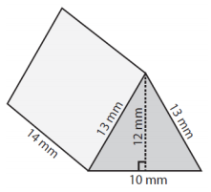
Question 1 Question 2
Calculate the volume of: Calculate the volume:
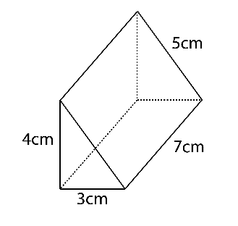
Question 3 Question 4
Calculate the exact (leave in terms of π) volume of: Calculate the volume of:
20cm
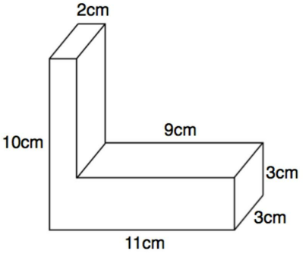
12cm
6cm

Question 5
A cube has a volume of 512cm³. What is its surface area?

Question 6
A glass box 7 x 12 x 18 cm, closed on all six sides, is partially filled with coloured water. When the box is placed on one of its 7 x 12 sides, the water level is 15cm above the table. If the box is placed on one of its 7 x 18 sides, what will be the water level above the table, in centimeters?

Question 7
A glass box, with a base measuring 15 x 12 cm and a height of 20 cm, is filled with water. Some of the water is then poured into a cylinder that has a radius of 7cm and is 20cm tall. If the cylinder is filled to the top, how high will the water be that remains in the original glass box.
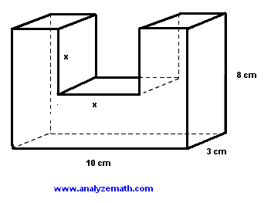
Question 8
Find the value of x so that the volume of the structure is 165cm³.

Answers
Question 1
$$V=\left(\frac{1}{2}×3×4\right)×7$$$V=42{cm}^{3}$
Question 2
$$V=\left(\frac{1}{2}×10×12\right)×14 \\ V=840{mm}^{3}$$
Question 3
$$A=π×6^{2}-π×3^{2}=27π \\ V=27π×20=540π{ cm}^{3}$$
Question 4
$$A=2×10+9×3=47 {cm}^{2} \\ V=47×3=141 {cm}^{3}$$
Question 5
$$V=512=x^{3} \\ x=8 cm \\ A=6×\left(8×8\right)=384 {cm}^{2}$$
Question 6
Volume of water = $7×12×15=1260 {cm}^{3}$
To find height: $V=1260=7×18×h$$$h=1260÷126 \\ h=10 cm$$
Question 7
$$V=15×12×20=3600 {cm}^{3}$$Volume of cylinder = $π×7^{2}×20=3078.76 {cm}^{3}$
Leftover water in box: $3600-3078.76=521.24 {cm}^{3}$
$$V=521.24=15×12×h \\ h=521.24÷180=2.9 cm$$
Question 8
Area of face = $8×10-x×x=80-x^{2}$
Volume = $3\left(80-x^{2}\right)=240-3x^{2}$
$$165=240-3x^{2} \\ 3x^{2}=75 \\ x^{2}=25 \\ x=5$$

Volumes of cones and pyramids
Much like a triangle is always half the area of a rectangle of the same base and height, a pyramid will always be one-third of the volume of the prism with the same base.
$$V=\frac{1}{3}×A×h$$
The shape of the base makes no difference, so this formula holds for cones, tetrahedron (triangle-based pyramids), rectangle-based pyramids and so on.
E.g. Calculate the exact volume of each of the pyramids
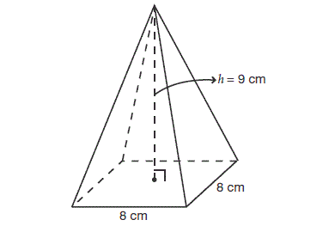
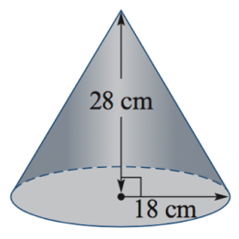

$V=\frac{1}{3}×π×{18}^{2}×28$ $V=\frac{1}{3}×8×8×9$
$V=3024π {cm}^{3}$ $V=192 {cm}^{3}$

Harder problems might require you to use Pythagoras’s Theorem to calculate the height:
E.g. Calculate the volume of the cone:
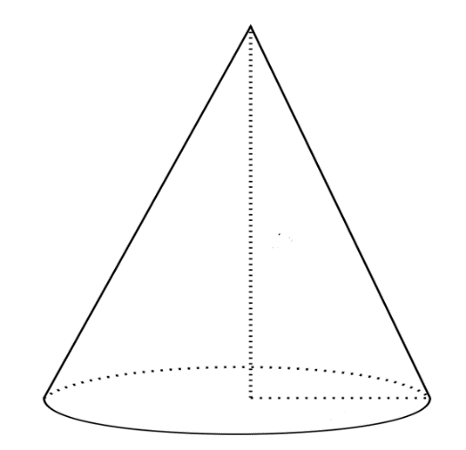
$h^{2}+{12}^{2}={20}^{2}$$$h^{2}={20}^{2}-{12}^{2} \\ h^{2}=256 \\ h=16 \\ V=\frac{1}{3}×π×{12}^{2}×16 \\ V=768π {cm}^{3}$$$V=2412.7 {cm}^{3}$ (1 dp)
h
20cm

12cm

Questions
Question 1
Calculate the volume of the cone
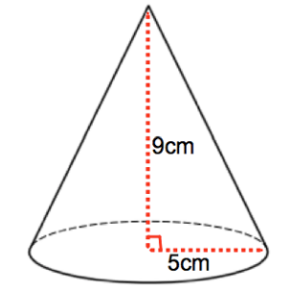
Question 2
Calculate the volume of the pyramid.
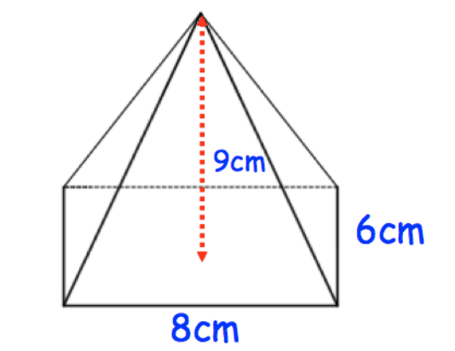

Question 3
A cone has a base diameter of 18 cm. The height of the cone is 20 cm.
Calculate the exact volume of the cone.

Question 4
A square-based pyramid has a base of side-length 15 cm. The perpendicular height of the pyramid is 10cm.
Calculate the volume of the pyramid.

Question 5
The volume of the cone below is 150 cm³. Calculate its height.
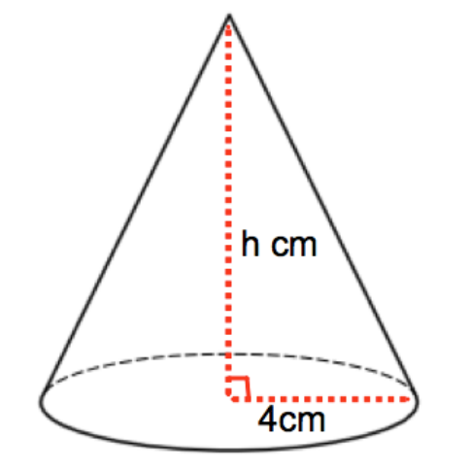
Question 6
Calculate the volume of the triangle-based pyramid.
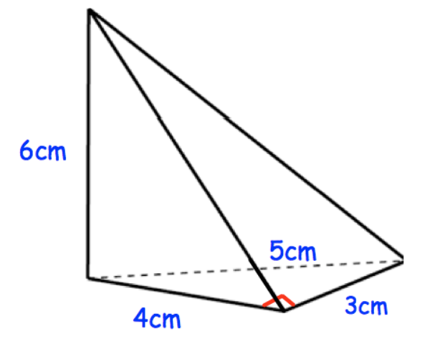

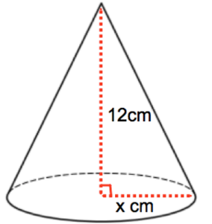
Question 7
The volume of the cone is 170 cm³. Calculate the radius of the base of the cone. Give your answer to 1 decimal place.

Question 8
Shown is a solid that is made up of a pyramid and a cuboid. Calculate the volume of the solid.
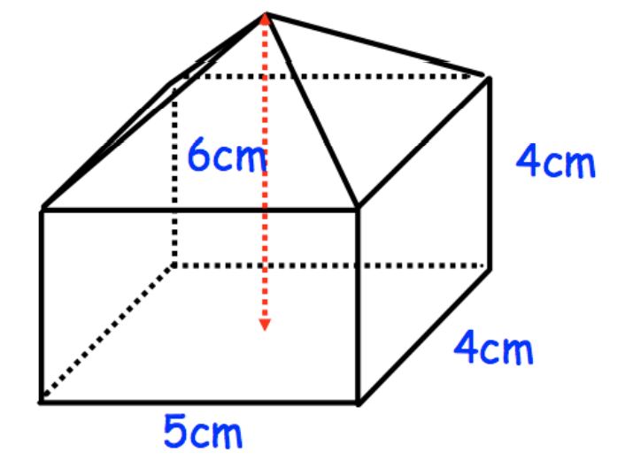

Question 9
Shown is a cone and a triangular prism. Both have the same volume. Calculate the height of the cone.
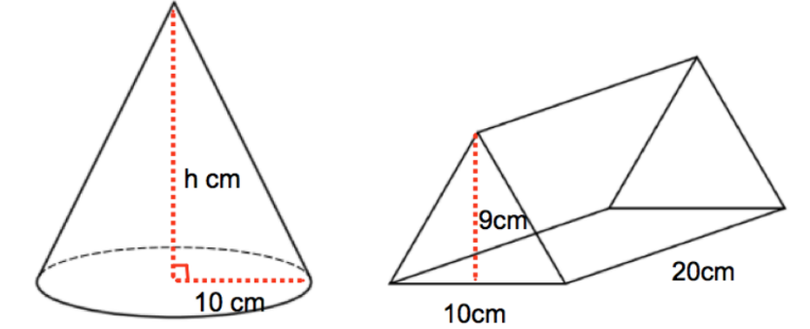

Question 10
A large cone is cut into two parts, a smaller cone and a frustrum of a cone (see diagram below).
The height of the large cone is 20cm and the radius of its base is 8cm.
If the radius of the base of the smaller cone is 4cm, what is the volume of the frustrum.
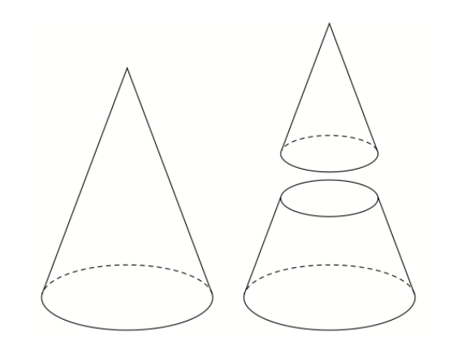
frustrum

Question 11
DEFG is a triangle-based pyramid. The base DEF is an equilateral triangle with side of 6cm.
If the perpendicular height is 4cm, what is the volume of the pyramid?
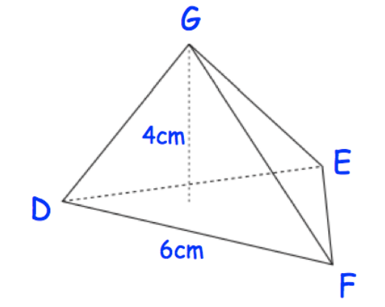
Question 12
Calculate the volume of the frustrum below.
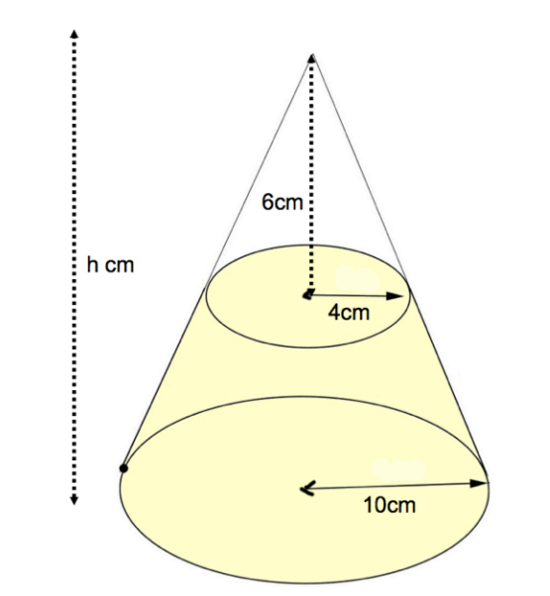

Question 13
a) If the radius and height of a cone are doubled in length, then by what factor will the volume of the cone be increased?

b) 100 cm3 is poured into the cone below. It comes to a height of 5cm, which is half the height of the cone.
How much water would be in the cone if it was filled to the top?
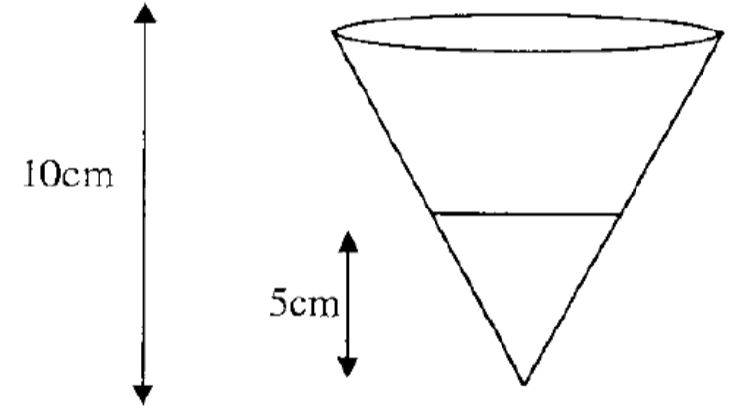

c) There is now a lid on the cone, and it is now turned over.
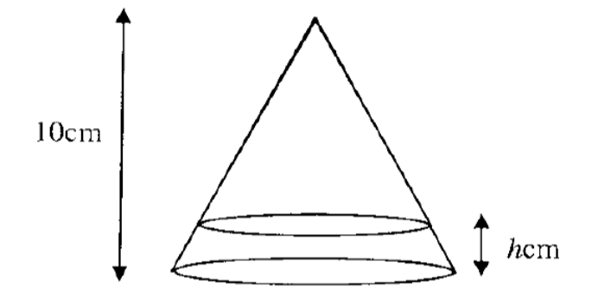
What will the height of the water be in the cone?

Answers
Question 1
$$V=\frac{1}{3}×π×5^{2}×9 \\ V=75π {cm}^{3} \\ V=235.6 {cm}^{3}$$

Question 2
$$V=\frac{1}{3}×8×6×9 \\ V=144 {cm}^{3}$$

Question 3
$$V=\frac{1}{3}×π×9^{2}×20 \\ V=540π {cm}^{3}$$

Question 4
$$V=\frac{1}{3}×15×15×10 \\ V=750 {cm}^{3}$$

Question 5
$$150=\frac{1}{3}×π×4^{2}×h \\ h=\frac{450}{16π}$$$h=8.95 cm$ (1dp)

Question 6
$$V=\frac{1}{3}×\left(\frac{1}{2}×4×3\right)×6 \\ V=12 {cm}^{3}$$

Question 7
$$170=\frac{1}{3}×π×x^{2}×12 \\ x^{2}=\frac{170×3}{12π} \\ x^{2}=13.53$$
$$x=3.68 cm$$

Question 8
Cuboid volume = $5×4×4=80 {cm}^{3}$
Pyramid volume = $\frac{1}{3}×5×4×2=13.3 {cm}^{3}$
Total volume = $93.3 {cm}^{3}$ (1dp)

Question 9
Prism volume = $\left(\frac{1}{2}×10×9\right)×20=900 {cm}^{3}$
$$900=\frac{1}{3}×π×{10}^{2}×h \\ h=8.59 cm$$

Question 10
Ratio of height : radius is the same for both cones.
$$\frac{20}{8}=\frac{h}{4}$$
Therefore, the height of the smaller cone is 10cm.
$$V=\frac{1}{3}×π×4^{2}×10=167.55 {cm}^{3}$$
Volume of large cone = $\frac{1}{3}×π×8^{2}×20=1340.4 {cm}^{3}$
Volume of frustrum = $1340.4-167.55=1172.85 {cm}^{3}$

Question 11
Area of triangle can be found by using the $1-2-3$ triangle
3
30º
6
$$3\sqrt{3}$$

$$A=\frac{1}{2}×6×3\sqrt{3}=9\sqrt{3}=15.6 {cm}^{2}$$
$$V=\frac{1}{3}×15.6×4=20.8 {cm}^{3}$$

Question 12
Ratio of height : ratio is the same for the larger cone and the smaller cone.
$$\frac{h}{10}=\frac{6}{4} \\ h=15$$
Volume of large cone = $\frac{1}{3}×π×{10}^{2}×15=500π {cm}^{3}$
Volume of small cone = $\frac{1}{3}×π×4^{2}×6=32π {cm}^{3}$
Volume of frustrum = $468π=1470.3 {cm}^{3}$

Question 13
a) $V=\frac{1}{3}×π×{\left(2r\right)}^{2}×2h$$$V=\frac{1}{3}×π×{4r}^{2}×2h \\ V=8\left(\frac{1}{3}πr^{2}h\right)$$
Therefore, the volume is increased eight-fold.

b) The larger cone is twice the height. The height and radius will be in the same ratio; therefore the radius will also be doubled. Therefore, therefore the volume will be increased by a factor of 8, meaning the volume is 800 cm³.

c) The upper cone will have 700 cm³ in it.
We know the ratio of the height to the radius will be the same, so if we work out the radius of the small cone from (b), we can form an equation to solve.
From (b): $100=\frac{1}{3}×π×r^{2}×5$
$$r=\sqrt{\frac{60}{π}}$$
Therefore, the ratio of radius : height is $\frac{r}{h}=\frac{\sqrt{\frac{60}{π}}}{5}=\sqrt{\frac{60}{25π}}$
$$r=\sqrt{\frac{60}{25π}}h$$
Substituting this into the volume equation for the upper cone in (c):
$$700=\frac{1}{3}×π×{(\sqrt{\frac{60}{25π}}h)}^{2}×h= \frac{20}{25}h^{3}$$
$$h=\sqrt[3]{\frac{700×25}{20}}=9.56cm$$
Therefore, the water is 10 – 9.56 = 0.44 cm deep.

Spheres

Volume
The volume of a sphere is given by the formula:
$$V=\frac{4}{3}πr^{3}$$

E.g.
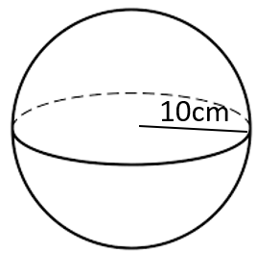
Volume = $\frac{4}{3}×π×{10}^{2}=\frac{400π}{3} {cm}^{3}=418.9 {cm}^{3}$

Surface area
The surface area of a sphere is exactly four times the area of its shadow. It is given by the formula:
$$A=4πr^{2}$$

E.g.

Surface area = $4π×{10}^{2}=400π {cm}^{2}=1256.6 {cm}^{2}$

Questions
Question 1
What is the volume and surface area of the sphere?
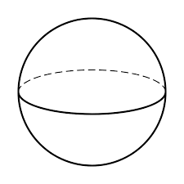
5cm
Question 2
A sphere has a surface area of 400 cm².
What is the volume of that sphere?

Question 3
A sphere has a volume of 5500 cm³.
What is the surface area of that sphere?

Question 4
What is the surface area of the hemisphere below? This should include the top.
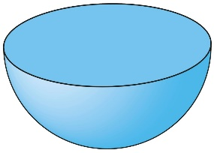
12cm

Question 5
I have a box of ice cream cones that are 15cm high, with a diameter of 6cm at the top. If I pack cones full of ice cream, and add a perfect hemisphere of ice cream on the top of each, how many ice creams can I serve from a 2 litre container? Note: 1 L = 1000ml = 1000 cm³.
6 cm
15 cm

Question 6
A cube with side lengths of 20cm has water in it up to a depth of 12cm. A sphere of radius 9cm is lowered into it. When the sphere is sitting on the bottom of the cube, how far from the top of the cube will the water be?

Question 7
A sphere is sitting tightly inside a cube.
a) If the sphere has volume 1200π cm³, what is the surface area of that cube?

b) If the length of the diagonal of one side of the cube is 20cm, what is the surface area of the sphere?

Question 8
A container is created from a cylinder and a hemisphere as shown below. Calculate the volume of the container.
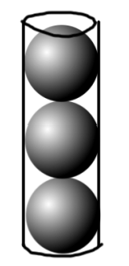
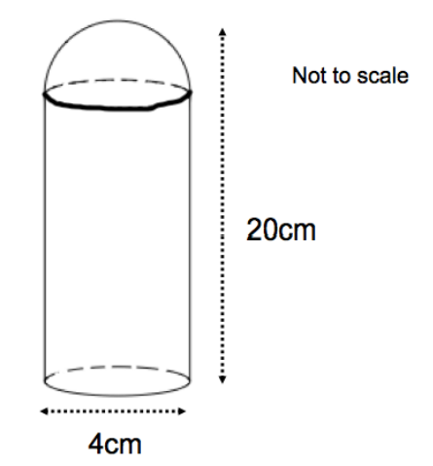
Question 9
Three spheres of radius 4cm fit perfectly inside a tube.
Calculate the percentage of the tube that is not filled.

Question 10
The sphere and the cone have the same volume.
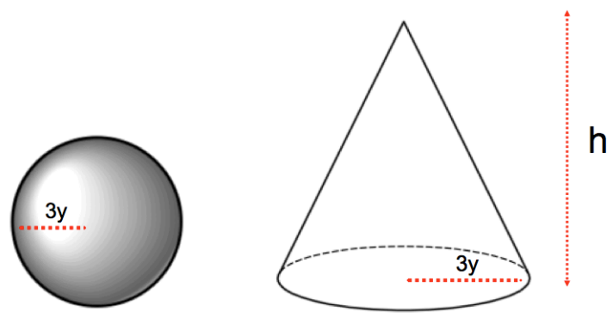
Find an expression for h in terms of y.

Answers
Question 1
$$V=\frac{4}{3}×π×5^{3}=\frac{500π}{3}=523.6 {cm}^{3} \\ A=4×π×5^{2}=100π=314.2 {cm}^{2}$$

Question 2
$$4πr^{2}=400 \\ r^{2}=\frac{400}{4π} \\ r=5.64 cm \\ V=\frac{4}{3}×π×{5.64}^{3} \\ V=751.5 {cm}^{3}$$
Question 3
$$\frac{4}{3}πr^{3}=5500 \\ r^{3}=5500×\frac{3}{4}÷π \\ r^{3}=1313 \\ r=10.95 cm \\ A=4×π×{10.95}^{2}=1506.7 {cm}^{2}$$
Question 4
Area = curved surface + circle top
$$A=\frac{1}{2}\left(4×π×{12}^{2}\right)+π×{12}^{2} \\ A=432π=1357.2 {cm}^{2}$$

Question 5
Volume of one ice cream = cone + hemisphere
$$V=\frac{1}{3}×π×3^{2}×15+\frac{1}{2}\left(\frac{4}{3}×π×3^{3}\right) \\ V=45π+18π=63π=197.9 {cm}^{3}=197.9 ml$$
Number of ice creams = $1000÷197.9=5$ ice creams

Question 6
Volume of cube = $20×20×20=8000 {cm}^{3}$
Volume of water = $20×20×12=4800 {cm}^{3}$
Volume of sphere = $\frac{4}{3}×π×9^{3}=3053.6 {cm}^{3}$
Total volume of water and sphere = $7853.6 {cm}^{3}$
Volume left in cube after sphere is added = $8000-7853.6=146.4 {cm}^{3}$
$$20×20×h=146.4 \\ h=0.37 cm$$

Question 7
a) $\frac{4}{3}πr^{3}=1200π$$$r^{3}=900 \\ r=9.65$$
Cube side lengths are $9.65×2=19.3 cm$
Surface area = $6×\left(19.3×19.3\right)=2234.9 {cm}^{2}$

b) If we set the side length of the cube to x:
$$x^{2}+x^{2}=400 \\ 2x^{2}=400 \\ x^{2}=200 \\ x=14.14 cm$$
The radius of the sphere is half of the side length, 7.07 cm.
$$A=4×π×{7.07}^{2}=628.1 {cm}^{2}$$

Question 8
Volume = cylinder + hemisphere
Radius of cylinder and hemisphere = 2cm, therefore height of cylinder = 18cm
$$V=π×2^{2}×18+\frac{1}{2}\left(\frac{4}{3}×π×2^{2}\right) \\ V=72π+\frac{8}{3}π \\ V=234.57 {cm}^{3}$$

Question 9
Length of tube = 3 x 8 = 24cm
Volume of tube = $π×4^{2}×24=384π {cm}^{3}$
Volume of spheres = $3\left(\frac{4}{3}×π×4^{3}\right)=256π {cm}^{3}$
Volume not filled = $384π-256π=128π$
Percentage not filled = $\frac{128π}{384π}×100=33.3\%$
Question 10
Volume of sphere = $\frac{4}{3}×π×{(3y)}^{3}=36πy^{3}$
Volume of cone = $\frac{1}{3}×π×{(3y)}^{2}×h=3πy^{2}h$
$$3πy^{2}h=36πy^{3} \\ y^{2}h=12y^{3} \\ h=12y$$

Units of measure

Distance is measured in units based on metres. I.e., kilometres, centimetres and millimetres.
Area is measured in units², like m², cm², mm².
Volume is measured in units³, like m³, cm³, mm³.
Liquid volume is measured in litres and millilitres, with 1 ml = 1cm³.
Weight is measured in units based on grams. I.e., kilograms, milligrams, micrograms. 1000kg = 1 ton

Metric distance
1 km = 1000 m
1 m = 100 cm
1 cm = 10 mm

Area
1 hectare (ha) = 10,000 m²

Liquid
1 Litre (L) = 1000 ml
1 ml = 1 cm³

Weight
1 tonne (t) = 1000 kg
1 kg = 1000 g
1 g = 1000 mg

Investigation
Here is a video of a swimming pool being filled. How long will it take to fill a swimming pool that is 5.3m in diameter to a depth of 1m?
https://youtu.be/bNXzHJGARS8?t=371
What information will you need?

Areas of regular n-gons
Now we look at how to calculate the area of regular polygons with more than 4 sides, such as pentagons or hexagons. These are generally known as n-gons, or polygons with n sides. We can find these by breaking the shape up into triangles.
A useful measurement is the apothem. This is the shortest distance from the centre of the shape out to the perimeter. It always hits a side at its centre and at right-angles (a perpendicular bisector).
For example, in a hexagon:

Questions
Question 1
If we are given the apothem of a regular n-gon with side lengths of s, what would be the formula for its area?

Answers

The Volume of Maths
A series of vessels of uniform cross section look like letters when viewed face-on. They are 1cm deep, and the corners of the vessels have either whole or half cm values for their coordinates.
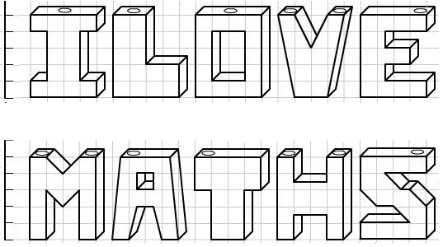
Water is poured slowly into each vessel through one of the holes at the top at a rate of 1cm³ per minute.
Seven of these vessels take the same time to fill up. Which are they?
Which one takes the longest to fill?
Which would fill up first?
The height of the water in one of the vessels is measured and a chart of the height against time is plotted, as follows:
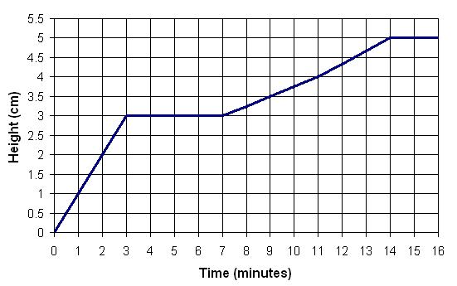
Which vessel does this chart correspond to? Can you explain what each part of the chart corresponds to?
The very observant solver might have noticed that the chart given is actually slightly inaccurate: at certain points it is an over-measurement and at certain points it is an under-measurement. Can you see where and why?
Make charts of height against time for some of the other letters.

Money, money, money!
During Maths Week, the winners of a competition have to choose which prize they want. Each prize is a square on the ground covered by coins.
These are shown below.
Prize 1: Prize 2: Prize 3:
$2 coins covering this space
1m
1m
$1 coins covering this space
1.5m
1.5m
50c coins covering this space
2m
2m

Diagrams are not drawn to scale.

Prize 4: Prize 5:
10c coins covering this space
4m
4m
20c coins covering this space
3m
3m

In your group, decide which prize they should choose.
Justify your choice. Show your working.

